UNITED STATES
SECURITIES AND EXCHANGE COMMISSION
WASHINGTON, D.C. 20549

FORM 8-K

CURRENT REPORT

PURSUANT TO SECTION 13 OR 15(d) OF THE
SECURITIES EXCHANGE ACT OF 1934

Date of Report (Date of earliest event reported): May 22, 2024

Nano Nuclear Energy Inc.
(Exact name of registrant as specified in its charter)

Nevada |  | 001-42044 |  | 88-0861977
(State or other jurisdiction  of incorporation) |  | (Commission  File Number) |  | (IRS Employer  Identification No.)

10 Times Square, 30th Floor
New York, New York 10018
(Address of principal executive offices, including zip code)

Registrant’s telephone number, including area code: (212) 634-9206

Not Applicable
(Former name or former address, if changed since last report)

Check the appropriate box below if the Form 8-K filing is intended to simultaneously satisfy the filing obligation of the registrant under any of the following provisions:

 | ☐ | Written communications pursuant to Rule 425 under the Securities Act (17 CFR 230.425)
 | ☐ | Soliciting material pursuant to Rule 14a-12 under the Exchange Act (17 CFR 240.14a-12)
 | ☐ | Pre-commencement communications pursuant to Rule 14d-2(b) under the Exchange Act (17 CFR 240.14d-2(b))
 | ☐ | Pre-commencement communications pursuant to Rule 13e-4(c) under the Exchange Act (17 CFR 240.13e-4(c))

Securities registered pursuant to Section 12(b) of the Act:

Title of each class |  | Trading  Symbol(s) |  | Name of each exchange on which registered
Common Stock, par value $0.0001 per share |  | NNE |  | The Nasdaq Stock Market LLC

Indicate by check mark whether the registrant is an emerging growth company as defined in Rule 405 of the Securities Act of 1933 (§230.405 of this chapter) or Rule 12b-2 of the Securities Exchange Act of 1934 (§240.12b-2 of this chapter).

Emerging growth company ☒

If an emerging growth company, indicate by check mark if the registrant has elected not to use the extended transition period for complying with any new or revised financial accounting standards provided pursuant to Section 13(a) of the Exchange Act. ☐

Item 8.01 Other Events.

As previously reported, on May 10, 2024, Nano Nuclear Energy Inc. (the “Company”) consummated its initial public offering (the “Offering”) of an aggregate of 2,562,500 shares of the Company’s common stock, par value $0.0001 per share (the “Common Stock”) at a price of $4.00 per share, generating gross proceeds of $10,250,000. In connection with the Offering, the Company granted the lead managing underwriter an option (“Over-allotment Option”), exercisable for 30 days from May 7, 2024, to purchase up to an additional 384,375 shares of Common Stock (the “Over-allotment Shares”) from the Company at the Offering price, less the underwriting discount, to cover over-allotments in the Offering.

On May 21, 2024, the underwriter exercised the Over-allotment Option in full, and on May 22, 2024, the closing of the purchase of the Over-Allotment Shares occurred, generating gross proceeds to the Company of $1,537,500 and net proceeds of approximately $1,414,500.

On May 22, 2024, the Company issued a press release announcing the full exercise and closing of the Over-Allotment Option. A copy of the press release is filed as Exhibit 99.1 to this Current Report on Form 8-K and is incorporated by reference herein.

Item 9.01 Financial Statements and Exhibits.

(d) Exhibits

The following exhibits are being filed herewith:

Exhibit No. |  | Description
99.1 |  | Press Release, dated May 22, 2024

SIGNATURE

Pursuant to the requirements of the Securities Exchange Act of 1934, the registrant has duly caused this report to be signed on its behalf by the undersigned hereunto duly authorized.

Dated: May 22, 2024 | Nano Nuclear Energy Inc.
 | By: | /s/ James Walker
 | Name: | James Walker
 | Title: | Chief Executive Officer

Exhibit 99.1

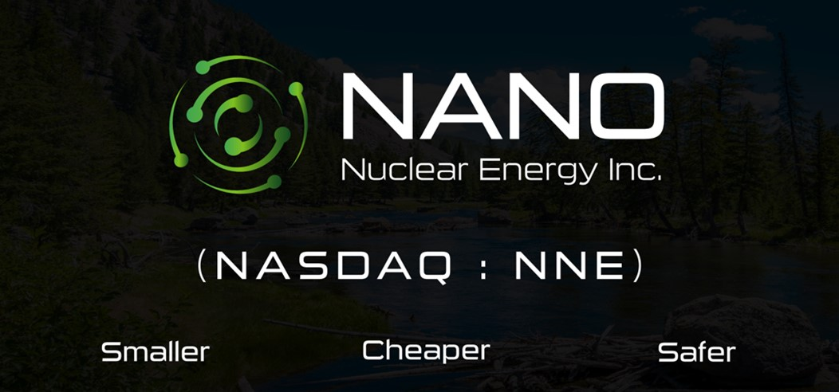

NANO Nuclear Energy Announces Closing of Full Over-Allotment Option from Initial Public Offering

New York, N.Y., May 22, 2024 — NANO Nuclear Energy Inc. (NASDAQ: NNE) (“NANO Nuclear”), an emerging vertically integrated microreactor and advanced nuclear technology company led by a world-class nuclear engineering team developing proprietary, portable, and clean energy solutions, is pleased to announce the closing today of the sale of an additional 384,375 shares of its common stock at $4.00 per share pursuant to the full exercise of underwriter’s over-allotment option granted in connection with the NANO Nuclear’s initial public offering which closed on May 10, 2024.

The gross proceeds from NANO Nuclear’s initial public offering, inclusive of the full over-allotment exercise, before deducting underwriting discounts and commissions and other offering expenses, were approximately $11,787,500, and net proceeds were approximately $10,460,560.

NANO Nuclear’s common stock is traded on the Nasdaq Capital Market under the symbol “NNE”.

NANO Nuclear believes that it is the first U.S. publicly listed company focusing on the design and development of portable, nuclear microreactors. According to the U.S. Department of Energy, microreactor designs vary, but most are designed to produce 1 to 20 megawatts of thermal energy that could be used directly as heat or converted to electric power. NANO Nuclear’s current microreactor designs are for reactors that would produce 1 to 5 megawatts. In addition, unlike other small or micro nuclear reactor companies, NANO Nuclear is seeking to become diversified and vertically integrated with multiple potential streams of revenue, including microreactor development, nuclear fuel fabrication and nuclear fuel transportation.

NANO Nuclear intends to use the net proceeds from its initial public offering to continue the research and development of its proprietary microreactor designs, ‘ZEUS’ and ‘ODIN’; advance its exclusive patented license to transport commercial quantities of HALEU fuel needed for the future of the advanced nuclear industry; develop a domestic source for a High-Assay, Low-Enriched Uranium (HALEU) fuel fabrication pipeline for NANO Nuclear’s own microreactors and the broader advanced nuclear reactor industry, as well as general corporate purposes and working capital.

The Benchmark Company, LLC acted as the sole book-running representative for the offering. Ellenoff Grossman & Schole LLP acted as counsel to NANO Nuclear. Lucosky Brookman LLP acted as counsel to The Benchmark Company. Withum Smith+Brown PC are NANO Nuclear’s registered independent auditors.

A registration statement relating to NANO Nuclear’s initial public offering was filed with the Securities and Exchange Commission and was declared effective on May 6, 2024. This registration statement can be obtained by visiting the SEC website at www.sec.gov. Please see such registration statement for additional information regarding NANO Nuclear.

This press release shall not constitute an offer to sell or the solicitation of an offer to buy these securities, nor shall there be any sale of these securities in any state or jurisdiction in which such offer, solicitation or sale would be unlawful prior to registration or qualification under the securities laws of any such state or jurisdiction.

About NANO Nuclear Energy Inc.

NANO Nuclear Energy Inc. (NASDAQ: NNE) is an emerging, advanced technology-driven nuclear energy company seeking to become a commercially focused, diversified, and vertically integrated company across four business lines: (i) cutting edge portable microreactor technology, (ii) nuclear fuel fabrication, (iii) nuclear fuel transportation and (iv) nuclear industry consulting services. NANO Nuclear believes it is the first nuclear microreactor company to be listed publicly in the U.S.

Led by a world-class nuclear engineering team, NANO Nuclear’s products in technical development are “ZEUS”, a solid core battery reactor, and “ODIN”, a low-pressure coolant reactor, each representing advanced developments in clean energy solutions that are portable, on-demand capable, advanced nuclear microreactors.

Advanced Fuel Transportation Inc. (AFT), a NANO Nuclear subsidiary, is led by former executives from the largest transportation company in the world aiming to build a North American transportation company that will provide commercial quantities of HALEU fuel to small modular reactors, microreactor companies, national laboratories, military, and DOE programs. Through NANO Nuclear, AFT is the exclusive licensee of a patented high-capacity HALEU fuel transportation basket developed by three major U.S. national nuclear laboratories and funded by the Department of Energy. Assuming development and commercialization, AFT is expected to form part of the only vertically integrated nuclear fuel business of its kind in North America.

HALEU Energy Fuel Inc. (HEF), a NANO Nuclear subsidiary, is focusing on the future development of a domestic source for a High-Assay, Low-Enriched Uranium (HALEU) fuel fabrication pipeline for NANO Nuclear’s own microreactors as well as the broader advanced nuclear reactor industry.

For more corporate information please visit: https://NanoNuclearEnergy.com/

PLEASE FOLLOW OUR SOCIAL MEDIA PAGES HERE:

NANO Nuclear Energy TWITTER

NANO Nuclear Energy LINKEDIN

NANO Nuclear Energy YOUTUBE

Cautionary Note Regarding Forward Looking Statements

This news release and statements of NANO Nuclear’s management in connection with this news release or related events contain or may contain “forward-looking statements” within the meaning of Section 21E of the Securities Exchange Act of 1934, as amended, and the Private Securities Litigation Reform Act of 1995. In this context, forward-looking statements mean statements related to future events, which may impact our expected future business and financial performance, and often contain words such as “expects”, “anticipates”, “intends”, “plans”, “believes”, “potential”, “will”, “should”, “seek,” “could”, “would” or “may” and other words of similar meaning. These forward-looking statements (including statements regarding our business plans and objectives as described herein) are based on information available to us as of the date of this news release and represent management’s current views and assumptions. Forward-looking statements are not guarantees of future performance, events or results and involve known and unknown risks, uncertainties and other factors, which may be beyond our control. For NANO Nuclear, particular risks and uncertainties that could cause our actual future results to differ materially from those expressed in our forward-looking statements include but are not limited to the following: (i) the early-stage nature of our company and the significant time and funding it will take to reach the regulatory approval and revenue generating stages; (ii) risks related to our U.S. Department of Energy (“DOE”) nuclear fuel manufacturing submission and the development of new or advanced technology, including difficulties with design and testing, cost overruns, development of competitive technology, (iii) our ability to obtain contracts and funding to be able to continue operations; (iv) risks related to uncertainty regarding our ability to commercially deploy a competitive advanced nuclear microreactor technology, (iv) risks related to the impact of government regulation and policies including by the DOE and the U.S. Nuclear Regulatory Commission; and similar risks and uncertainties associated with the business of an early-stage up business operating a highly regulated industry. These risk factors may not constitute all factors that could cause actual results to differ from those discussed in any forward-looking statement. Also, these and other risks concerning our programs and operations are described in additional detail in our Registration Statement on Form S-1, which was declared effective on May 6, 2024, and our other SEC filings, which can be accessed at https://www.sec.gov and our website at https://ir.nanonuclearenergy.com/financial-information/sec-filings. Accordingly, readers are cautioned not to place undue reliance on these forward-looking statements, which apply only as of the date of this news release, and all forward-looking statements should not be relied upon as a predictor of actual results. We do not undertake and expressly disclaim any obligation to update our forward-looking statements to reflect events or circumstances that may arise after the date of this news release, except as required by law.

For further information, please contact:

Email: | IR@NANONuclearEnergy.com
Business Tel: (212) 634-9206

